Future Prediction of Stock Market with Moving Average Crossover Strategy
Mohib Billah Siddiquee, Shah Md. Wahid, Ashrif Sharlimin Siaum,
Rafik Un Nabi Apu, Abdullah Basher Rumi

Department of Computer Science and Engineering, BRAC University, 66 Mohakhali
, Bir Uttam AK Khandakar Road, Dhaka -1212, Bangladesh
<Mohib.Bracu, Shahmdwahid10, ashrif.sharlimin, rafik.nabi007, basher_rumi> @gmail.com

Abstract. Nowadays data science is playing a crucial role in every aspect of our everyday life. Our main goal is to use this data science approach to get information and bring out the best outcome regarding the information. Predicting stock market was not so easy in last century. Now we have many machine learning algorithm and data set available for predicting the future outcome of stock market. In this paper we are describing our method of prediction. This study aims to answer whether an optimized moving average crossover strategy based on daily data outperforms a buy and hold strategy. The paper investigates the use of an optimized moving average crossover strategy. In our result there will be a curve to take decision when to buy or when to sell.
Keywords : Stock market prediction, Moving average crossover strategy, Financial Markets, Trading Strategy
1 Introduction
1.1 Motivations
In recent times with increasing population and advancement of technology, we still fail to predict the share market, as our success is not known to everyone and sometimes we still don’t know where to invest. Suppose someone has the urge to buy BSRM shares, however the shares has not increased in last two years. If this type of incident occurs more often, then BSRM is not a good investment for the investors. Also, the share market is open to share their information. We will use that information to analyze them and figure out if any company is suitable for investment. Thus, people will be able to determine that particular share buying is a good investment or not.
1.2 Data Science , Data Mining and Machine learning

Data science is the mash up of discipline including math, mathematical theorem, applied algorithms, engineering and technologies, domain expertise and many more. It is an approach to analyze any type of data and get result from it.
Machine learning is the ability of a system to learn without being explicitly programmed. Basically it’s a way to make a decision from a set of data. Data mining is a branch of machine learning. Data mining is the process of examining a set of data and produce a desired output.Here, in our project we will use data science .

1.3 An overall idea

We have collected data from internet and we modified it. It is a classified dataset. Then we had to select `the algorithm for our task. We decided what we want to have in our outcome. We firstlly planned to do it with nural network but we faced some problem. Then we changed the algorithm. We then decided to do it with moving average crossover strategy.

2 Methodology

The moving average crossover strategy is geared toward finding the middle of a trend. A trend defines price action in which prices move in a specific direction over a period of time. Generally, trends are either upward or downward, as sideways movements are considered consolidation and not trends. Most of the time—approximately 70%—capital markets trade in tight consolidative patterns and only trend 30% of the time. With this in mind, it is important to be able to define a trend and jump on as soon as it is recognizable.

2.1 How to Capture a Trend
Short-term trends can be captured using short-term moving averages. A moving average is the average of a specific period, and when a new data point is added, the first period of the average is dropped. A moving average crossover strategy looks for periods when a short-term moving average crosses either above or below a longer-term moving average to define a short-term trend. Longer moving averages are gauged to capture longer-term trends within a financial market. When the 20-day moving average of gold prices crosses below the 50-day moving average, as seen in the chart of gold, a medium-term trend is considered in place.
For example, when the 5-day moving average of the usd/jpy prices crosses above the 20-day moving average of usd/jpy prices, a short-term trend could be considered in place. One trading technique could be to purchase the usd/jpy prices when the moving averages cross over looking to ride an uptrend in the currency pair. By combining a short and long-term moving average, an investor can attempt capture up, down, and sideways movements.

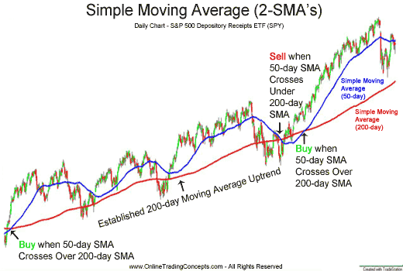
Figure 1. Moving average of 50 and 200 days

2.2 Formulation
In our project we have taken data with high, low, adj close and close column. We are using the adj close column to predict. Firstly, we are taking 28 days mean for mv1 then we are taking 260 days mean to calculate mv2. Then we are converting the series to frame. Then adding new header into column. After adding all the columns together we will check for the nan values. If there is zero in any row ,it is dropped. Then we will be able to see the result in chart. There will be a square curve for buy and sell decision.

3. Result and discussion

In our project we have made a decision curve with moving average data MA1, MA2. According to our result the MA1(average of 28 days) is almost near to the close but the MA2(moving average of 260 days) shows a difference from close. SO, we predict two ways. One for long term buy and sell and another for short term buy and sell. This was a problem to decide. But in the second curve we can see the buy and sell decision. Moreover, we can predict now with a labeled dataset.
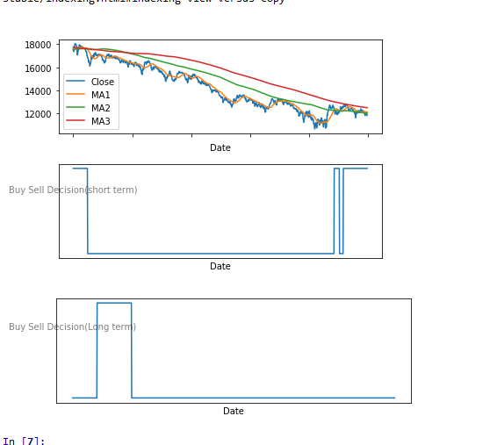
Figure 2. Final results
4. Conclusion
To conclude, there are many algorithm and many ways to predict the future of share market with the previous dataset. People have done this prediction with moving average crossover but our project is different in comparison with them. The main significance of our project is we are using two moving average. Our aim was to indicate the buy and sell position for finding the time to buy and sell shares.

References
1. Youngohc yoon and George swales. "Predicting stock price performance: a neural network approach". IEEE publishing, 1991.

2. Shapiro, A. C. (2006), Multinational Financial Management, 8: th edition, USA: John, Wiley & Sons

3. Praekhaow, Puchong. (2010). Determination of Trading Points using the Moving Average Methods.

4. Michalewicz, Z.: Genetic Algorithms + Data Structures = Evolution Programs. 3rd edn. Springer-Verlag, Berlin Heidelberg New York (1996)

